Name: Ali Albayrak

Student ID: P304320

Portfolio 2-4

Vocabulary:

HashSet: A set similar to an ArrayList without any specific ordering.

List: An ordered Collection that may contain duplicates.

Collections: An interface used to define a group of objects. This includes lists and sets.

ArrayList: A list that is very similar to an array.

Set: A Collection of elements that does not contain any duplicates.

1.What is the difference between a set and a list?

Set is a collection that does not contain any duplicates. List may contain duplicates.

2. You decide you want to roll 2 dice and see what the frequency is of each possible number combination. Would you use a Set collection to do this? State your reason(s).

I would not use a set for this example. Because of sets don’t contain duplicates, I can’t keep record for frequency of rolled numbers.

3. Using a collection create a variable that will store a list of countries (Strings). Your collection should not store duplicates, and order is not important. Test your code by adding 6 countries, one of which is a duplicate.

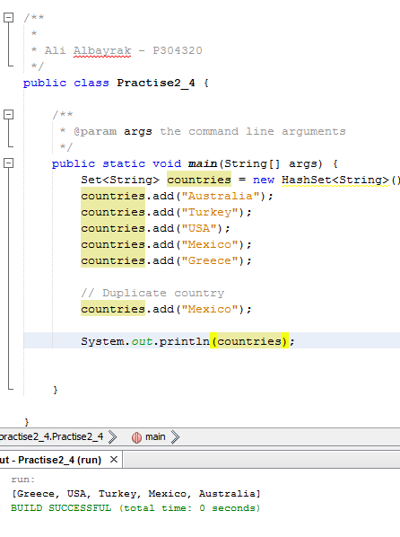

4. Would the following Collection.sort() statements both work? Explain your answer.

HashSet<String> countriesSet = new HashSet<String>();

Collections.sort(countriesSet);

ArrayList<String> countriesList = new ArrayList();

Collections.sort(countriesList);

First statement of sort will not work. Because HashSet doesn’t have any order. However, second sort method will work because we can sort ArrayList.

5.

When we use Generic ArrayList implementation, we don’t have to worry about array size or overflow situations. Also, ArrayList has add and get method by default. So, we don’t have to write another method for those. Moreover, If we want to know about the current size of the arraylist, we can use size() method.

